Shun can console similar to the Linux terminal, you can perform basic Linux commands on the inside, you need to have a Linux foundation  
Proper use

Ls command lists the file list  
1. ls (list) command is a very useful command is used to display a list of files and subdirectories in the current directory. With parameters  
Used in a different way to display directory contents. Examples are as follows:  
Display the contents of the current directory:  
[ai-thinker @ localhost ai-thinker] $ ls  
Desktop mail myinstall.log test.txt ← two directories and two folders  
When you run the ls command does not display names. "" Beginning of the file. So you can add them to list -a parameter specifies the text  
Pieces. Examples are as follows:

[ai-thinker @ localhost ai-thinker] $ ls -a  
-s Parameter to display each file all the space, and -S parameter to specify the size of the space occupied by all sorted. Examples are as follows:  
[ai-thinker @ localhost ai-thinker] $ ls -s -S  
Total 36  
4 Desktop 4 mail 24 myinstall.log 4 test.txt  
Add the directory path to be displayed directly in the ls command will list the contents of the directory. Examples are as follows:  
[ai-thinker @ localhost ai-thinker] $ ls -l / usr / games  
2. Change directory cd command

cd (change directory) command allows the user to cut the directory currently resides. Examples are as follows:  
[ai-thinker @ localhost home] $ cd ai-thinker ← switch to the current ai-thinker subdirectories  
[ai-thinker @ localhost ai-thinker] $ cd .. ← switched to the parent directory  
[ai-thinker @ localhost home] $ cd / ← switch to the system root directory  
[ai-thinker @ localhost /] $ cd ← switch to the user's home directory  
[ai-thinker @ localhost ai-thinker] $ cd / usr / bin ← switch to the / usr / bin directory  
3. Create a directory mkdir command  
Mkdir (make directory) command can be used to create a subdirectory. The following example creates a subdirectory under the directory tool

Record.  
[ai-thinker @ localhost ai-thinker] $ mkdir tool  
4. Delete the directory rmdir command  
rmdir (remove directory) command can be used to remove the empty subdirectories. Examples are as follows:  
[ai-thinker @ localhost ai-thinker] $ rmdir tool ← delete tool catalog  
5. Copy the file cp command  
cp (copy) command to copy files from one place to another. Generally use the cp command will copy a file to another  
When a file or copied to a directory, you need to specify the original file name and destination file name or directory. Examples are as follows:  
[ai-thinker @ localhost ai-thinker] $ cp data1.txt data2.txt ← will be copied into the data2.txt data1.txt  
[ai-thinker @ localhost ai-thinker] $ cp data3.txt / tmp / data ← Copy data3 to / tmp / data directory  
The copy process: the process of adding the -v parameter to display the command execution. Examples are as follows:  
[ai-thinker @ localhost ai-thinker] $ cp zip.txt zip2.txt ← general state of the copy process will not be displayed  
[ai-thinker @ localhost ai-thinker] $ cp -v zip.txt zip3.txt ← -v to display the copy process zip.txt -> zip3.txt  
Re delivery system: adding --R‖ parameters can also copy all the files and subdirectories. Examples are as follows:  
[ai-thinker @ localhost ai-thinker] $ cp -v -R * backup ← all files (including subdirectories files) to  
backup directory

6. Delete the file or directory rm command  
rm (remove) command to delete a file or directory. Examples are as follows:  
[ai-thinker @ localhost ai-thinker] $ rm myfile ← delete the specified file  
[ai-thinker @ localhost ai-thinker] $ rm * ← delete all files in the current directory rm commands commonly used parameters such as  
Next:  
Forced Delete: When using the -f parameter, rm command to delete the file directly, not ask. Examples are as follows:  
[ai-thinker @ localhost ai-thinker] $ rm -f * .txt ← forced to delete files  
Recursive delete: -r is a very commonly used parameters, use this parameter to delete all files and subfolders in the specified directory  
Table of Contents. Examples are as follows:  
[ai-thinker @ localhost ai-thinker] $ rm -r data ← delete the data directory (all files and subdirectories containing the data directory  
Record)  
[ai-thinker @ localhost ai-thinker] $ rm -r * ← delete all files (including all the files in the current directory and all subdirectories  
Subdirectories and files)  
Forced to delete the specified directory: When you use the -r parameter to delete a directory, if there are a lot of files and subdirectories in the directory, the system will  
Continuously asked to confirm that you really want to delete the directory or file. Ruoyi you sure you want to delete directories and files stored, you can  
Use -rf parameters, this way, the system will delete all files in the directory and subdirectories, not ask. Paradigm  
As follows:  
[ai-thinker @ localhost ai-thinker] $ rm -rf tmp tmp directory and forced to delete all the files and subdirectories in the directory  
Delete process: Use the -v parameter. Examples are as follows:  
[ai-thinker @ localhost ai-thinker] $ rm –v

2. Firmware generation  
Automatically generates compiled firmware firmware are generated in the bin directory

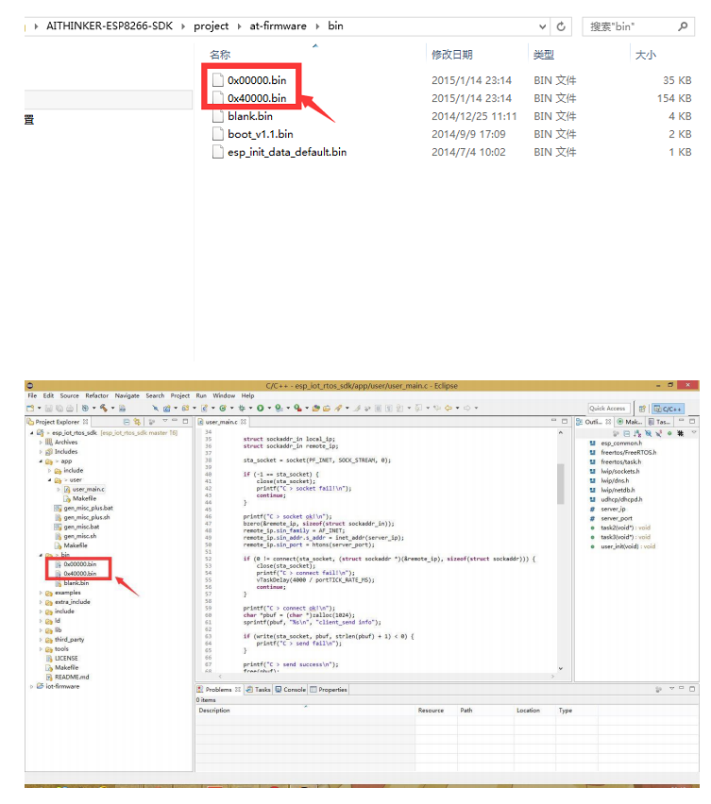

3. Firmware programming  
The firmware can be programmed using a key programming tool can also be used esptool.py  
A key programming tool Description:

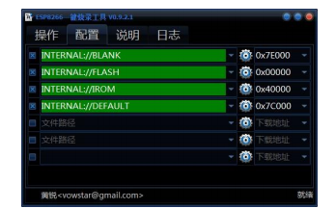

Select the box to the left to choose whether to download the firmware, firmware middle path can be entered manually, or you can click on the "tooth  
Wheel "icon to browse to select the most right is programmed address. If there is only one firmware, you only need to select one and  
The address is set to 0x00000. If you have multiple firmware, follow the instructions to set the address according to the official. Tip: Use the mouse wheel  
You can quickly set the address.  
EspTool Description  
An Open Letter to the console, cd to the directory firmware proceed as follows (subject to the address when the actual firmware programming required):  
esptool.py --port com3 write_flash 0x00000 0x00000.bin 0x40000 0x40000.bin

Shun Technology ESP8266 module can be compiled platform  
DE environment Introduction  
Advantages: no installation, no virtual machines, compile speed  
IDE compiler friendly editing interface



The above documents will be unpacked  
Double-click to open ESP8266IDE

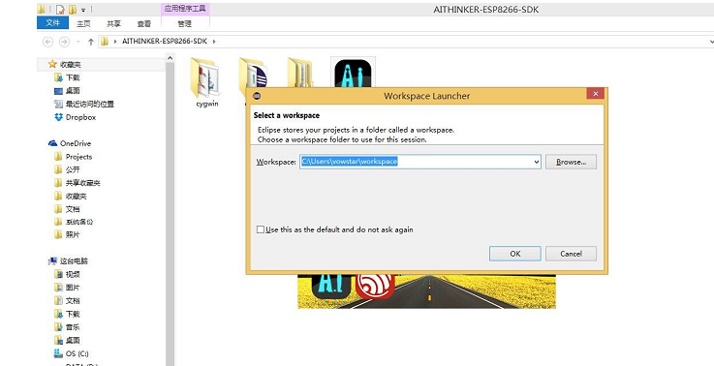

Select a Workspace and then wait for the progress bar went head

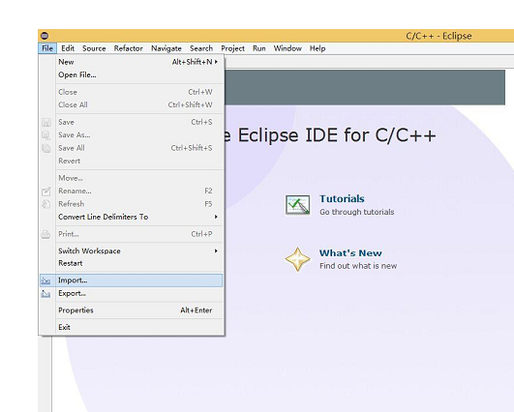

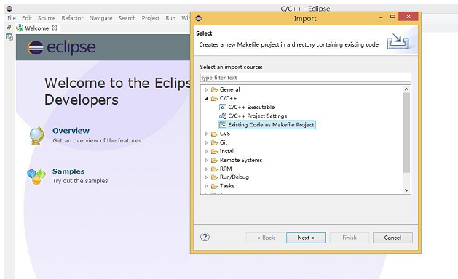

Browse to a project to compile, compiler option Cygwin

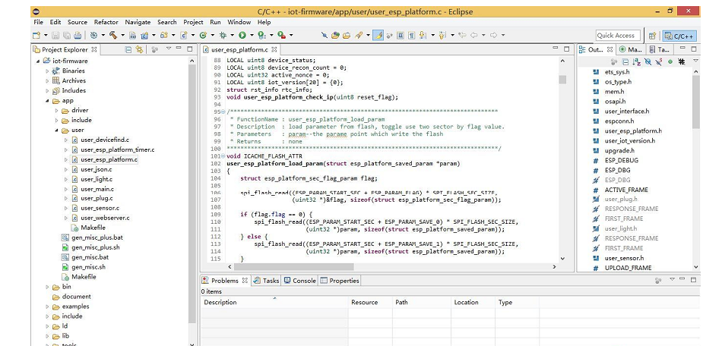

Then all the advanced features are out, code completion, automatic code analysis, code tracking

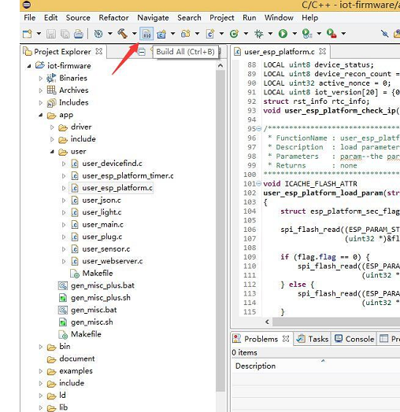

Click this button, or press Ctrl + B to compile the whole project  
After compilation you need to perform firmware gen_misc generated at the console, and use a key programming tool programming  
You can

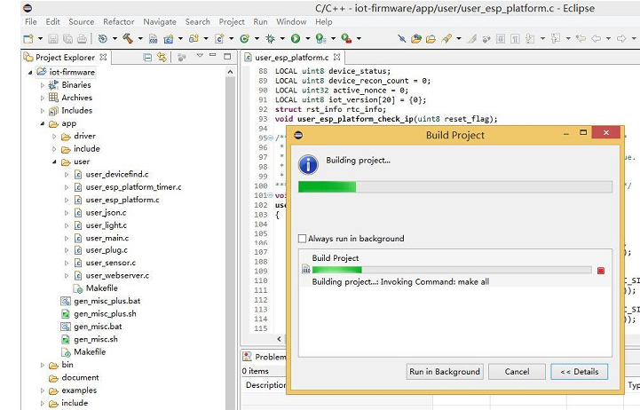

Compile time will display a progress bar  
Good computer performance, it is less than 20 seconds on the OK  
"Shun can ESP8266SDK", contains the IDE environment, console programming tools  
And Source

Our front desk after this time ESP8266  
+ RTOS + NodeMCU together integrated into the IDE